# Octave Tutorial Commands

Matrix Arithmetic

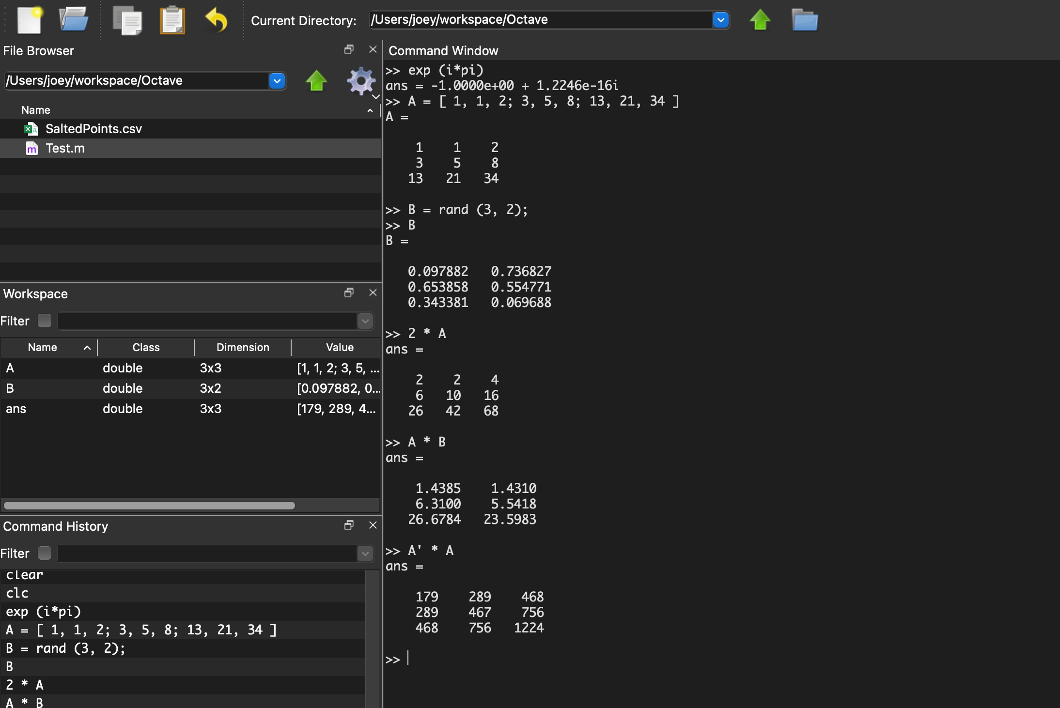

Differential Equations

